Instructions on Customer Impact Model
The new public rate impact model for BP-14 compares BP-12 customer rates to BP-14 final rates in three ways:
- Effective rate change from BP-12 to BP-14. This rate is taken as the revenue collection under all customer charges, load shaping, and demand rates (net of discounts) for non-slice sales by customer divided by total customer load and is denominated in $/MWh. BP-12 is compared to BP-14. Does not include customer REP Refund Amounts.
- Rate Change Only. This method takes the BP-14 forecast billing determinants assumed in setting BP-14 final rates, and applies BP-12 and BP-14 rates to these constant billing determinants (net of discounts). A rate change is then computed from BP-12 to BP-14 final rates.
- Hybrid Approach. BPA Staff argue that since rates are now denominated in terms of a share of the BPA system, and since that system is not necessarily equal across rate periods, holding system size constant in evaluating a rate change by customer is imperfect. An attempted solution is the hybrid approach, whereby we take BP-12 Tier 1 System and RHWM values as fixed, and apply the updated 2014 load forecast to conditions as if we were in 2012. Therefore, 2014 loads are held constant, but not the system or RHWM allotments of the system to individual customers. BY 14 billing determinants assume the 2014 Tier 1 System and RHWM allotments. Then, BP-12 rates are applied to the recalculated BP-12 billing determinants (assuming the 2014 load and CSP forecasts), and BP-14 rates are applied to the BP-14 billing determinants. A rate change is then computed from BP-12 to BP-14 final rates.
Setting the Hybrid approach.
On the Init tab, select the cell R9, and change to “Yes”.
Setting the Rate Change Only approach.
On the Init tab, select the cell R9, and change to “No”.
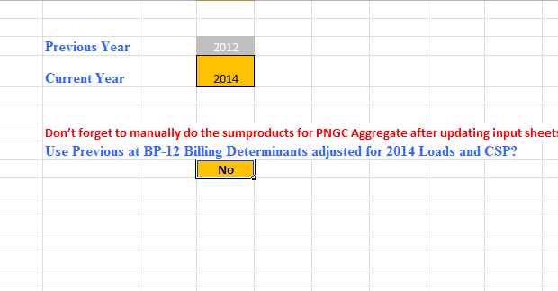
Model Results are stated in the “Outputs” Sheet, and include:
- Rate Increase Including Slice and LS – Does not include the value of slice secondary, but does include the value of firm slice sales
- Rate Increase NonSlice – excludes the value of the slice product (firm and secondary).
- Rate Increase NonSlice and Previous LS Rates – removes the effect of load shaping rate changes by equalting the load shaping rates across periods.
- Rate Increase NonSlice and Excluding Load Shaping – removes the effect of load shaping billing determinant and rate changes by removing the load shaping charges altogether in both periods. (not used in charts)
- Rate Increase NonSlice Effective Rate to Effective Rate – always computed whether or not Hybrid or Rate Change Only approaches are used.
Graphs are included showing rate changes from smallest customer to largest, cumulative, and Effective rate change only (approach #1 above). Samples are below from BP-14 final.

